
CeCe J’S SNACKS CAPSTONE PROJECT

Team Vision
Project Proposal Report

12/02/2022

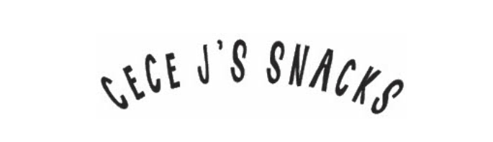

Submitted to:
Cece J’s Snacks,
Cecelia Jackson,
1006 Hanover Ave, Allentown, PA 18109.
Submitted by:
Team Vision
Aditya Ravi, Mohamed Nawara, Amar Ezzat Beck, Brandon Soriano, Difan Zeng, Travis Allen

Advisor: Charlie Purdum
Y N
X | Intellectual Property Rights Agreement Applies
X | Non-Disclosure Agreement Applies

EXECUTIVE SUMMARY

CeCe J’s Snacks is a dried fruit snack company based in Allentown, PA, which is operated and run by Cecelia Jackson. CeCe J’s Snacks sells high quality dried fruit snacks made from natural ingredients and no added chemicals or preservatives. However, being a small growing business, the company is facing issues with achieving operational efficiency and keeping up with the demand. The team has been tasked with helping CeCe J’s Snacks with these issues and improving the business functions to increase revenue and help grow the company.
The first objective of this project is to analyze the current workplace and identify areas of improvement. Currently the company employs two workers (other than Cecelia), and the company itself has only been active for approximately 3 years. The sponsor is acquiring a new space for her company to operate within; therefore, the team will design a new layout that follows her recommendations and increases the overall efficiency of production. Several new areas will be implemented in the new design such as a break/meeting room and a personal office for the sponsor which are currently not present.
The second objective (concurrent with the first objective) is to create an optimization plan for the sponsor’s current workspace, and future workspace, to identify areas to optimize efficiency for production. This encompasses many factors such as suggestions for new machinery, additional tools for production, and a simulation model.
The AutoCAD software will be used to create the 2-Dimensional model of the new workspace. It will demonstrate the new process layout for the production line, resulting in an increase in the total number of units produced yearly, even throughout the seasonal spikes. A detailed section in this report will be designated for the optimization plan. The deliverables for this project include a final report, final poster, a summary video, and a CAD file. The final report will act as a walkthrough of the project’s subsequent steps executed throughout the semester. The budget required for this project is estimated to be approximately $200 for purchasing some devices and travel. The software is provided by the institution. With the help of these tools, the team will aim to achieve the goals and deliverables set in order to satisfy the client in reaching their business goals for the fiscal year.

TABLE OF CONTENTS

Team Vision i
EXECUTIVE SUMMARY ii
TABLE OF CONTENTS iii
1.0 INTRODUCTION 1
2.0 PROBLEM STATEMENT 2
3.0 PROJECT OBJECTIVES 3
4.0 APPROACH 4
4.1 Statement of Work 5
4.2 Schedule 7
5.0 BENEFITS 8
6.0 DELIVERABLES 8
7.0 BUDGET NARRATIVE 9
REFERENCES 10
APPENDIX A: PROJECT BUDGET 11

1.0 INTRODUCTION
The team has been assigned to CeCe J’s Snacks LLC, a small business operating in Allentown, PA. The company caters to the food-service industry by manufacturing various kinds of dried fruit snacks. Ceceila, the owner of CeCe J’s Snacks LLC, began her company with no culinary experience. She has successfully managed to grow her business in a brief period, as she now delivers to 22 different colleges, hospitals, hotels, and the food industry. CeCe J’s Snacks sell high quality dried products, made from natural ingredients. They produce 26 products, of which 4 are present in the market. She now wishes to acquire a new space of land to be utilized upon for operations, additional machineries, and potentially expanding her production team. As a small business, she continuously deals with heavy competition from large commercial snacking brands.
CeCe J’s Snacks has a set process that is critical for their production of snacks. They order different fruits from Kaegals (local farmers market) and certain vendors. The fruits are inspected for defects, before it is washed and sanitized. A particular machine will then cut the fruits into thin slices. The slices are then prepped with toppings made from different ingredients. Once this is done, the dehydrator uses trays to heat and dry the chips 14 trays at a time. Each product has different temperature requirements; hence, temperature settings must be adjusted to compensate for it. The product is then placed on the tray, and the tray is placed back into the machine. The printer will then print the labels. The operators will taste the product to ensure quality. Once quality inspection is complete, the tray is placed off the machine. Each product is placed in their designated bag (separated from one another). The sealing machine is used to seal the bag, and the bags are placed in the labelled boxes. Floor operators will record the necessary information for the batch.
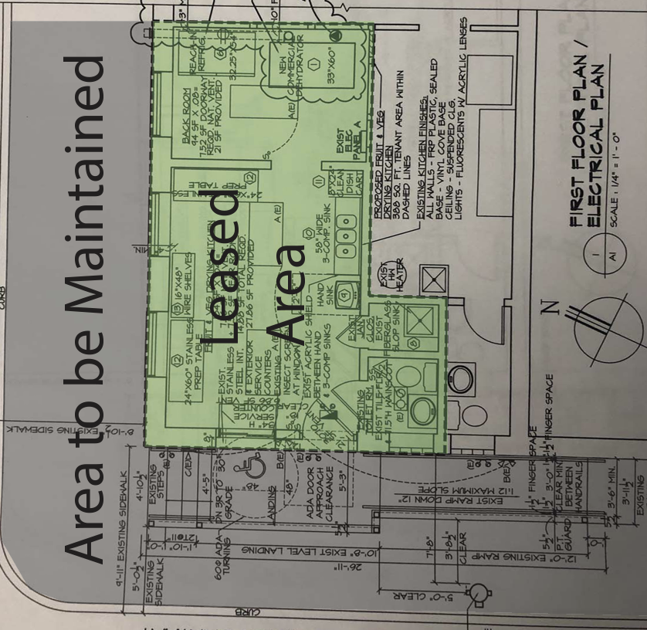
Figure 1: Cece J’s Current Workspace (Blueprint)

2.0 PROBLEM STATEMENT

CeCe J’s snacks are delivered to 22 different colleges, hospitals, hotels, and the food service industry. For a busy production, Cecelia’s current operation has 2 employees working 8 hours a day. This current process requires several hours to complete production of products, and it is all documented and tracked on an Excel sheet. They have identified that there is an opportunity to improve efficiency by redesigning the overall layout of production. Cecelia wishes to acquire a larger piece of land to be used for additional machinery, place of production, personal office, break/meeting room, and potentially additional employees for future production. The blueprints for the current workspace are given to the team to analyze the several factors that lead to inefficiencies of production.
As revealed by the sponsor, 85% of the business is seasonal (i.e., golf courses, theme parks, college campuses), thus it is imperative to maximize operations during these times to meet high demands. The main issue for the current floor plan is the size and location of the dehydrator, it is not effective to meet these high demands with only 3 operators. The sponsor has revealed that an additional employee will significantly increase production levels. The team will utilize the new area to include additional employees, who will be operating at a higher efficiency level (faster rate). The AutoCAD software will be used to design the layout in a 2-dimensional model, where the new space acquired will be demonstrated. Other variables such as equipment relocation, cost of relocating and new machinery, and an effective flow system will also have to be planned and delivered through the CAD model.
Specifications of different machinery, shipping costs, quantities, and tools, will be documented and presented to the sponsor for the future workspace that she will acquire, and recommendations to the current workspace will also be presented. Also, for the current workspace, a simulation model will be used to depict the current system for the company and find areas for improvements.

3.0 PROJECT OBJECTIVES

The main objective for this project is to design a 2D layout for the new space that the sponsor will acquire, and identify the appropriate placement for production, inventory, and raw material. Another objective is to create an optimization plan for the current workspace and future workspace for the company. This will document all the specifications for the additional machineries, and tools that can be used for the current workspace and future workspace.
SMART objective for the design plan:
- Create a 2D model layout for the new space by using the AutoCAD software provided by the institution.
- Complete one section of the layout every other week by drawing the initial ideas (with dimensions) of the floor plan, then translating it onto the AutoCAD software for accurate representation.
- Given the size of this team, and the skills acquired from the institution, this plan is agreed-upon and attainable to achieve by the deadlines set by the project supervisor.
- A completed and revised 2D CAD model will demonstrate a new layout plan to the supervisor of the optimized production space. Several new areas will be added to the layout such as a personal office, break/meeting room, and inventory space. Several factors will also be considered such as additional employees, new machineries, and tools.
- The desired goal is to complete the final AutoCAD design by December 1st, 2022. This can be accomplished when the team begins the initial design plans in October, follow the bi-weekly goals set the previous week, and implement the recommendations made by the project supervisor and sponsor.

If these objectives are met over the course of this project’s duration, the sponsor will see an increase in efficiency with the newly acquired space. The team estimates a larger production output of products to meet high demands. The CAD model will hopefully present a reduction in the amount of worker movement across the production floor, and a smoother production line. The model should also satisfy the sponsor’s wishes and recommendations for the new space.

The secondary objective is to study the current production process and suggest improvements on it by conducting research on integrating more technology into the system. With the help of better than

4.0 APPROACH

The team identified that there are two main tasks to complete, therefore the team will split into two. The design team (Aditya, Mohammad and Amar) will primarily focus on Task 1, which is designing the future workspace and incorporating all the previously listed factors. The optimization team (Difan, Travis and Brandon) will focus on Task 2, which relates to delivering a document of listed potential products, machineries, and tools with their respective specifications. A Gantt chart, shown in Figure 2, will provide an overall scope of the project execution.
Task 1 primarily focuses on designing a future workspace, implementing all the recommendations listed by the sponsor, and incorporating the products suggested by the optimization team. To begin this task the design team should get an understanding of the overall floor area of the future workspace.
Task 1.1, conducting a site visit to record down all the necessary measurements of work- related products on the site, machinery, and placement of work, as all of these will be carried to the new layout plan. Blueprints given from the sponsor will also be useful for measurements.
Task 1.2, drawing potential design options to discuss and evaluate areas of improvements and to ensure recommendations from both the sponsor and the optimization team are met. The final draft will be conducted in this task and presented to the project supervisor and sponsor.
Task 1.3, translating the final draft of the drawn layout to the AutoCAD software for the final deliverable. This will be the final layout for the future space that demonstrates all the sponsor’s recommendations, and that optimizes worker efficiency and production flow. Dimensions for all the parts will also be delivered.
Creating the AutoCAD model will show the team, project supervisor, and the sponsor a greater understanding of the overall layout of the new workspace. Different elements such as additional machineries, personal office, break/meeting room, will be demonstrated and incorporated in the 2D model.
Task 2 primarily focuses on delivering a document of listed products with their specifications in hopes of optimizing the current workspace and future workspace. This document will provide suggestions for the company for the current and future workspace.
Task 2.1, conducting research on the list of materials on the online marketplace (such as Amazon), including ones that can be purchased to assist with work optimization.
Task 2.2, providing an organized document that displays all the provided parts with their specifications.
Task 2.3, creating a simulation model on SIMIO software to demonstrate the process for the current workspace and identify areas of immediate improvement.
This document will be the source of suggestions/recommendations to the sponsor in order to optimize her current production line, and future production line.
Task 3 is delivering and completing the main deliverables that the team agreed upon at the start of the project. These deliverables include a final report, presentation, recorded video, poster, and the AutoCAD 2D model file. The final report will show screenshots of the AutoCAD model and a description of the process flow of the new layout for the future workspace. The report will also include a reported table of different findings created by the optimization team, along with recommendations to the sponsor and the overall execution of the project. The poster, video, and the presentation will summarize the group’s process throughout the project’s life, the results produced by the team, and the final recommendations and conclusions. The team will also present their work in the Bryce Jordan Center on Tuesday 6th December 2022.

4.1 Statement of Work

Task 1 and Task 2 will be handled by the design team and the optimization team, respectively. Design team involves Aditya Ravi, Amar Ezzat Beck, Mohammed Nawara. Optimization team involves Brandon Soriano, Travis Allen, Difan Zeng.
Table 1 will present each team member’s specific task to ensure a successful project completion.
Table 1: Statement of Work
Task + Activity | Required Resources | Timeline | Team Member(s)
Task 1: Initial drawings for the future layout | Paper, pencil, ruler, iPad. | November 15th - November 23rd | Aditya Ravi, Amar Ezzat Beck, Mohamed Nawara
Task 1: Translating the final draft drawing to AutoCAD | AutoCAD software | November 24 -December 1st | Amar Ezzat Beck, Aditya Ravi, Mohamed Nawara
Task 2: Work optimization ideas for current workspace | Laptop | November 9th – November 16th | Brandon Soriano, Difan Zeng, Travis Allen
Task 2: Creating a simulation software for current process | SIMIO software | November 10th - November 16th | Difan Zeng
Task 3: Poster | Laptop | November 29th -December 3rd | Aditya Ravi, Mohamed Nawara, Difan Zeng
Task 3: Video recorded presentation | Camera, laptop | November 29th -December 3rd | Aditya Ravi, Brandon Soriano, Travis Allen
Task 3: Gantt Chart | Laptop | October - December | Difan Zeng
Task 3: Final Report (Ex. Summary, Intro, Objectives, Approach, Deliverables) | Laptop | November 29th -December 3rd | Amar Ezzat Beck, Mohamed Nawara
Task 3: Final Report (Results) | Laptop | December 2nd -December 3rd | Amar Ezzat Beck, Brandon Soriano, Mohamed Nawara
Task 3: Final Report: Benefits | Laptop | December 29th -December 3rd | Amar Ezzat Beck, Mohamed Nawara
Task 3: Final Report: Schedule | Laptop | December 29th -December 3rd | Amar Ezzat Beck, Mohamed Nawara, Difan Zeng
Weekly Memo | Laptop | October-November | Amar Ezzat Beck

4.2 Schedule

A Gantt chart to highlight the project’s tasks to be completed on the specified due date. This will present the project’s management and ensure that the team completes the required tasks on time. Since the sponsor lost her new place after the team’s site visit. Changes were made to the previous plan and now have two schedules.

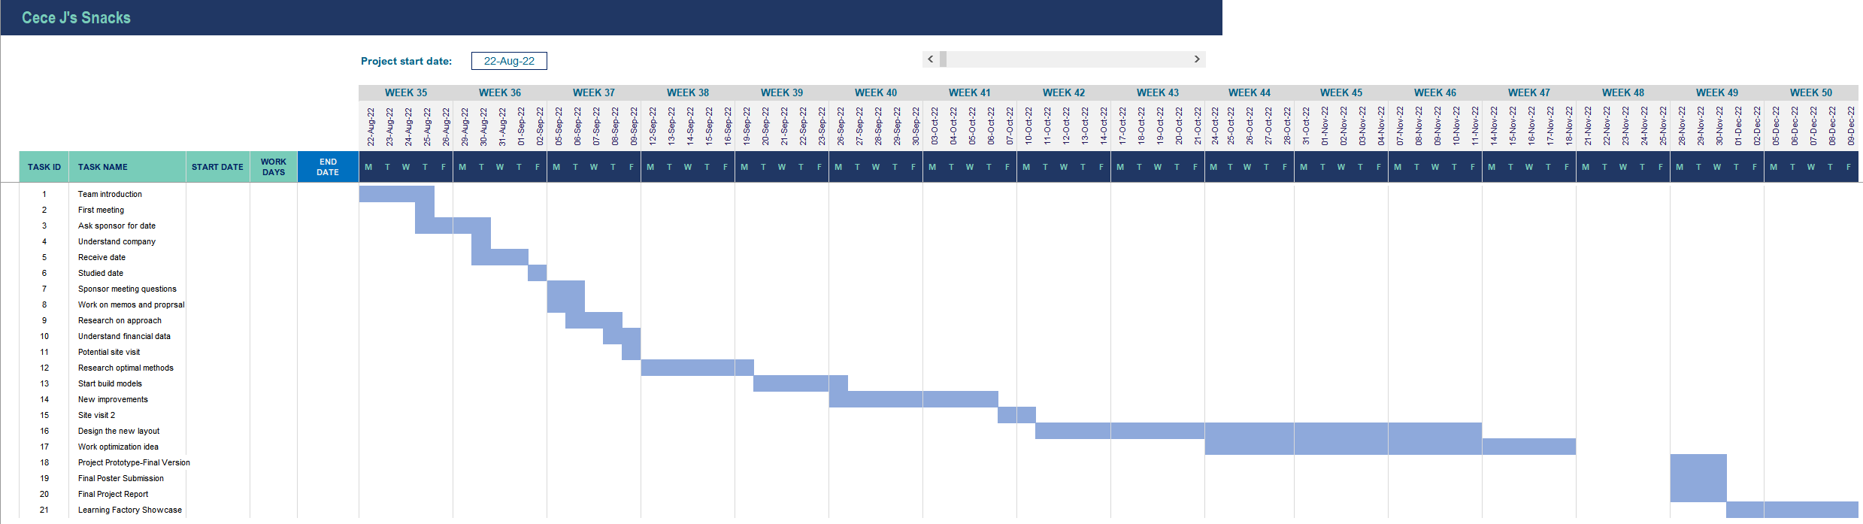
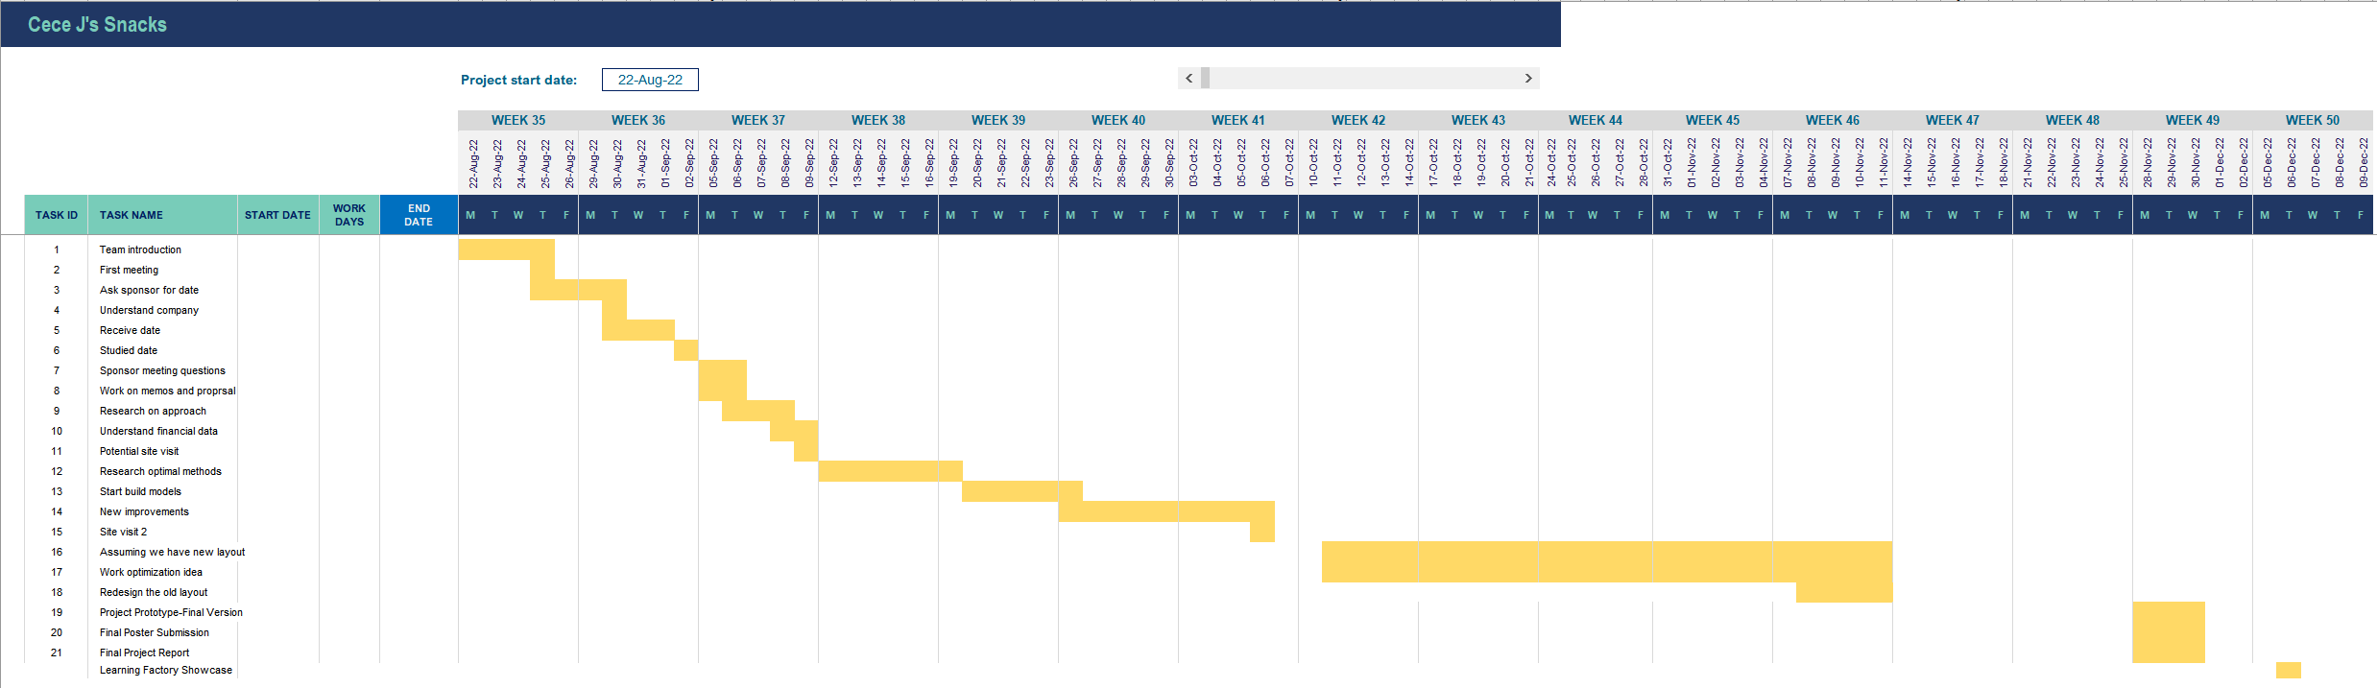Figure 2: Gantt Chart

5.0 BENEFITS

The main benefits of this project would be improving operational efficiency of production. The new workspace layout will show an improved process workflow, along with an improved inventory management system. This is important as it will leave the sponsor with a process with minimal waste (i.e., walk time) which leads to increased operational efficiency. The AutoCAD model will represent the overall goal of this project, through improving efficiency by incorporating suggestions from the sponsor, recommendations from the optimization team, and laying out a plan that ensures a stream flow of production.
New products recommendations such as machinery and tools can also lead to improved process times, which can also lead to minimal waste for the current workspace and future workspace. With these implementations, the sponsor should be able to handle the increased demand while dealing with less waste in the process itself, which leads to improved efficiency in the long-term. The sponsor can oversee the production flow from her personal office, and employee additional operators in the future to deal with the seasonal demands.

6.0 DELIVERABLES

In Table 2, the planned deliverables and expected dates have been placed in Table 2 for the team to follow.
- Final Report: This will contain all the information about the company, the problem objective that the team aims to achieve, the team’s approach to tackling the problems, the results from the design team, and the optimization team.
- Future Layout Workspace: This will be a 2D CAD model that demonstrates the final layout for the future workspace for the sponsor. It will also have the dimensions for all parts located on the production line.
- Final Report Presentation: This will be a presentation about the report to the project’s supervisor and sponsor.
- Learning Factory Deliverables: This will include the project’s poster, a recorded video summarizing the process of this project, and a one-page report summary of the project.

Table 2: Project Deliverables

Deliverable Name | Type (report, prototype, etc.) | Expected Delivery Date
Final Report | Report | 12/05
Future Layout Workspace | AutoCAD file | 12/05
Final Report Presentation | PowerPoint Presentation | 12/08
Learning Factory Deliverables | Poster, Video, One-Page Report | 12/06

7.0 BUDGET NARRATIVE

The main objective of this project involves the use of software that is provided by Pennsylvania State University. AutoCAD and SIMIO are both provided by the institution, and all the required materials are already owned by the team members. Therefore, the only anticipated expense will be from the travel to the worksite. The distance from State College to Allentown is approximately 165 miles. The average price of gas is $3.913 per gallon. Around 24 miles per gallon is approximated to be used for an average car. Therefore, $26.902 is the estimated cost for a one-way trip, and $53.803 for a full trip. The trip expects to make two trips total for the entirety of this project, thus $107.61 is the expected total cost for this project. This is summarized in Table 3, Appendix A.
Currently, there are no materials or parts that the team should acquire during this project. All the software are already provided by the institution, as previously mentioned.

REFERENCES
- The general format of the final report/proposal follows the proposal example provided by the IE480W class.
- Ceceilia (sponsor) was the main point of reference for Cece J’s Snacks, and all of its operations.

APPENDIX A: PROJECT BUDGET

Table 3: Project Budget Summary for September 2022-December 2022
Budget Item | Proposed | Interim | Actual
Travel | $110.00 | $88 | $198
Equipment | $90.00 | $0 | $90
Materials | $0.00 | $0 | $0
Miscellaneous  - Project poster  - Others… | $0.00 | $0 | $0
Total Project Costs | $200.00 | $88 | 288

